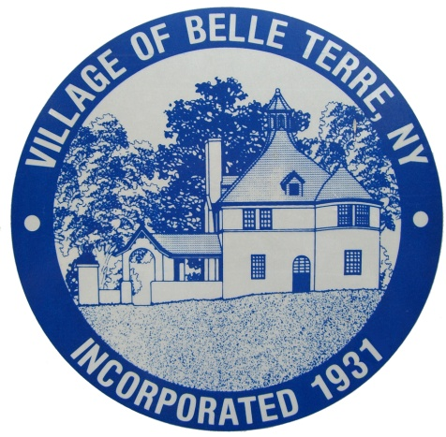

Estate Sale / Tag Sale

Issued to: ________________________________________________________________
Name and Address

Sale Location:_____________________________________________________________
Address

Dates and Times of Sale: ________________________________________________________

________________________________________________________
Dates and Times

Authorized Signature: _________________________________________ Title: _____________________

This permit allows you to place no more than 3 signs within the Village to direct people to the residence. These signs must be removed at the end of the day, each day of the sale. If needed, additional signs may be placed on the Village Bulletin boards. These signs must be removed after the last day of the sale.

Please understand that if it becomes necessary to have an extra constable on duty for traffic control in the immediate area, you will be charged at cost for the hours of extra coverage required.

Yours Truly,

Village Office

cc: Dave Wolosin, Chief Constable
Village Files

forms\Estate Sale Receipt # ______

